**45.1. AOP AOP and Spring MVC App – Overview**

**Goal**:

Here we want to add AOP logging support to our Spring MVC app (CRM Web App)

**Structure**:

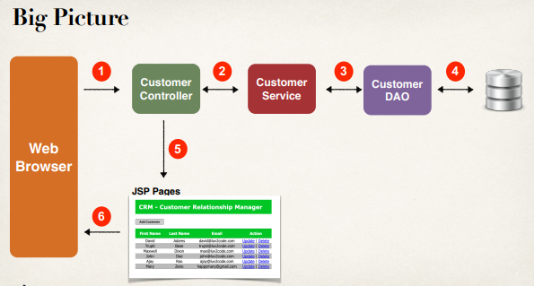

**Logging Aspect**:

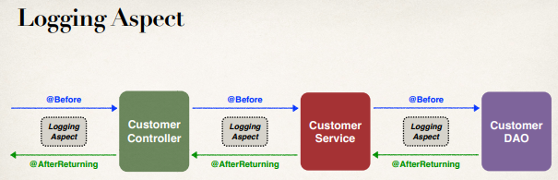

**Development Process (Step-by-Step)**:

1. Add AspectJ JAR file to web project
2. Enable AspectJ Auto Proxy
3. Create Aspect
   1. Add logging support
   2. Setup pointcut declarations
   3. Add @Before advice
   4. Add @AfterReturning advice

**Step 1: Add AspectJ JAR file to web project**:

* All Spring projects require AspectJ JAR file for AOP support
* Can download from
  + <http://www.luv2code.com/download-aspectjweaver>
* Add JAR file to your web project: **WEB-INF/lib** directory

**Step 2: Enable AspectJ Auto Proxy (XML)**:

<beans xmlns=*"http://www.springframework.org/schema/beans"*

...

xsi:schemaLocation=*"*

*...*

*http://www.springframework.org/schema/aop*

*http://www.springframework.org/schema/aop/spring-aop.xsd"*>

<!-- Add Aspect autoproxy support for AOP -->

<aop:aspectj-autoproxy />

...

</beans>

**Pointcut Declarations**:

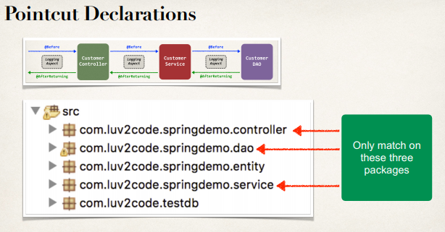

**Pointcut**:

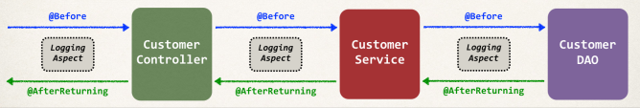

**Program Output match with pointcut**:

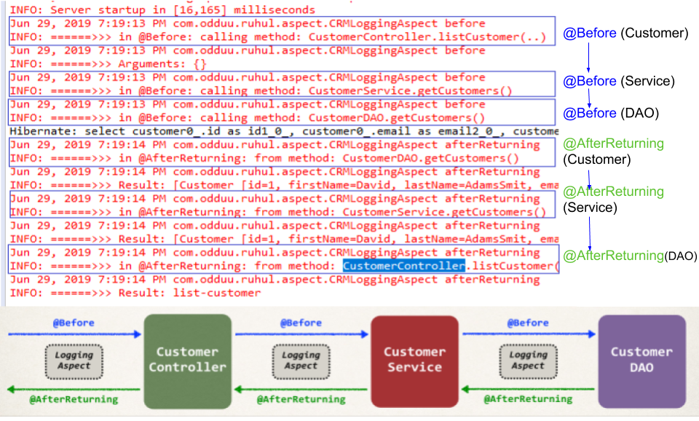

45.1. AOP AOP and Spring MVC App - Overview